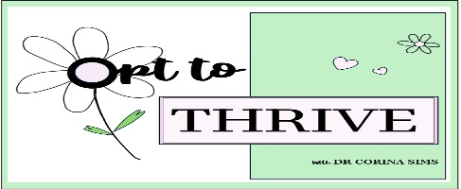

**Menopause Hormone Treatment/Hormone**

**Replacement Therapy**

Symptoms of perimenopause and menopause are due to a decrease in oestrogen. The majority of oestrogen in a woman’s body is produced by the ovaries. Once the ovaries have depleted their egg supply and therefore have completed their reproductive function they stop producing oestrogen. Menopause Hormone Treatment (MHT) previously known as Hormone Replacement Therapy (HRT) is an effective treatment for the symptoms of menopause. MHT treats the symptoms of menopause by supplementing the body with oestrogen. The formulations you may be offered are dependent on whether you still have your uterus (you have not had a hysterectomy).

Women who have had a hysterectomy can be treated with oestrogen only. For those who still have their uterus they will need both oestrogen and progesterone. In the course of a normal menstrual cycle there is a balance of these two hormones that build up the lining of the uterus to prepare for pregnancy and then shed it when pregnancy has not occurred. Without this balance oestrogen alone increases the risk of cancer of the uterus. This is why progesterone must be given to women with a uterus in order to protect the lining of the uterus and therefore reduce the risk of uterine cancer.

**MHT Formulations**

There are a number of MHT formulations available.

For women who do not have a uterus oestrogen can be taken by mouth in the form of a tablet or applied to the skin as a gel or a patch.

For women who do have a uterus oestrogen can be taken by mouth in the form of a tablet or applied to the skin as a gel or a patch. Progesterone can be given with oestrogen in a combined patch or tablet or it can be added to another form of oestrogen by way of a Mirena intrauterine device or a capsule.

MHT is safe for most women. Risks include:

* Blood clots - 1 extra case per 1,000 women if taking oestrogen tablets, minimal to no risk if patches and gels
* Heart disease – no increased risk if given within 10 years of onset of menopause or before the age of 60. There is some evidence there is a decreased risk in women taking oestrogen alone.
* Breast cancer - overall 1 in 8 women will develop breast cancer during her lifetime. The added risk of breast cancer with MHT is very small. The risk appears to start after 4-5 years of taking combined MHT. There is some evidence oestrogen alone decreases the risk of breast cancer.
* Stroke – For women under the age of 60, in the first 10 years of menopause, with no other stroke risk factors there is no increased risk. Women with risk factors can probably safely use a patch or gel form of treatment.

**Vaginal oestrogen therapy**

Vaginal oestrogen therapy is useful for women who have vulval or vaginal symptoms such as dryness, urinary symptoms or recurrent urinary tract infections. Vaginal oestrogen in prescribed doses is safe to use long-term.